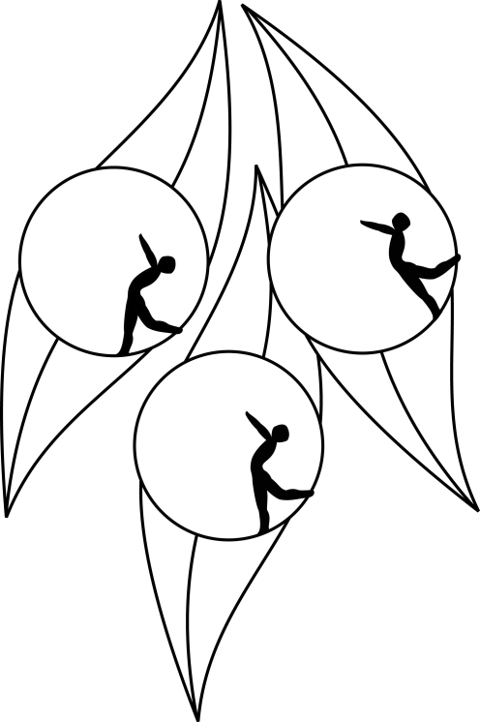
SOUTH AUSTRALIAN ICE SKATING ASSOCIATION Inc.

RESULTS

TEST SESSION

20 December 2009
Ice Arena, Thebarton

Congratulations to the following skaters

Elementary 2 Figure Pattern:
Amelia Davis

Elementary 1 Technical:
Natasha Colliver

Preliminary:
Indiana Murray
Sakura Conlon

